

19c rdbms installation on standalone server
Oracle 19c database version

Project



DISCLAIMER

This document is strictly private, confidential and personal to its recipients and should not be copied, distributed or reproduced in whole or in part, nor passed to any third party.

Version history
Date | Version | Description | Author
2021-11- | 1.0 | Initial Version | Karthikeyan Saravanan
2021-11-26 | 1.1 | Updated version | Sharang Dwivedi

Contents
Version history 3
1. Introduction 5
2. Prerequisite 5
3. rdbms binary installation 6

Introduction

This document describes the steps to install the 19c rdbms software on standalone server.

Prerequisite

- Grid installation should complete before proceeding with rdbms binary installation
- Rdbms binary, opatch and patching software location on server
$ cd /backup/Oracle19c_SW
$ ls -lrth
-rwxrwxrwx. 1 c949ks c949ks 2.7G Oct 28 11:14 LINUX.X64_193000_db_home.zip
-rwxrwxrwx. 1 c949ks c949ks 2.5G Oct 28 11:24 p30696566_198000DBRU_Linux-x86-64.zip
-rwxrwxrwx. 1 c949ks c949ks 116M Oct 28 11:36 p6880880_190000_Linux-x86-64.zip

Create oracle rdbms home /g01/app/grid/oracle19c
$ mkdir -p /u01/app/oracle/rdbms19c
Unzip the software to grid home
$ unzip -d /u01/app/oracle/rdbms19c /backup/Oracl19_SW/LINUX.X64_193000_db_home.zip

Remove the older version of OPatch (Rename instead of deleting)
$ cd /u01/app/oracle/rdbms19c
$ mv OPatch OPatch_BKP

Unzip the OPatch patch
$ unzip -d /u01/app/oracle/rdbms19c backup/Oracl19_SW/p6880880_190000_Linux-x86-64.zip

Verify OH patch version
$ export ORACLE_HOME=/u01/app/oracle/rdbms19c
$ export PATH=$ORACLE_HOME/bin:/usr/sbin:$ORACLE_HOME/OPatch:$PATH;
$ opatch version

Unzip patch 31305339 in another directory -> this patch to upgrade 19.3 to 19.8
$ cd /backup/Oracle19c_SW
$ unzip p31305339_190000_Linux-x86-64.zip

rdbms binary installation

Run the setup
$ cd /u01/app/oracle/rdbms19c
$ ./runInstaller -applyRU /backup/Oracle19c_SW/31305339/

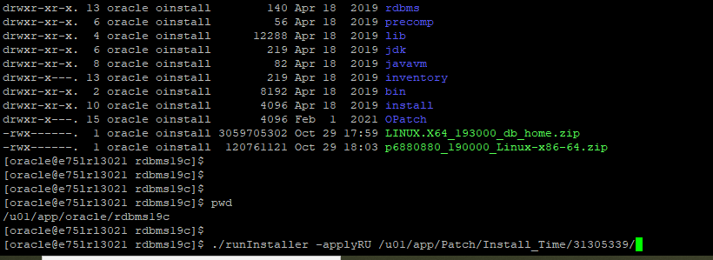
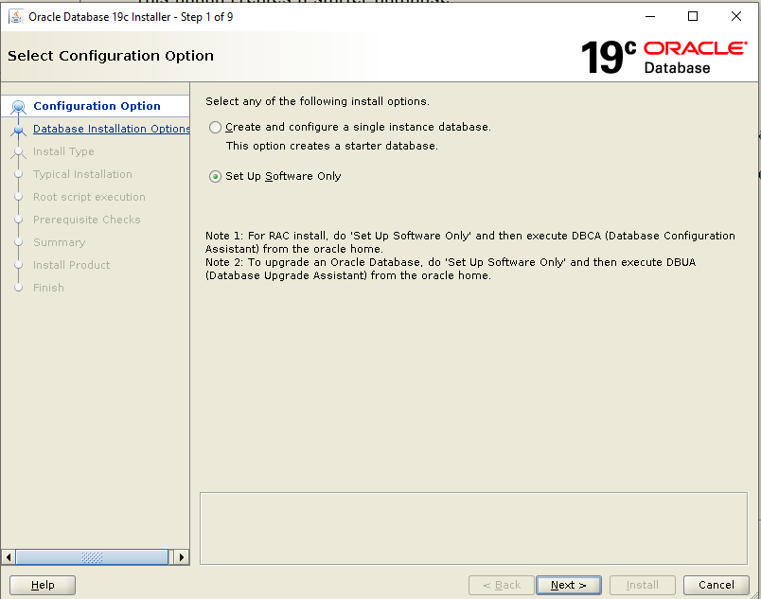

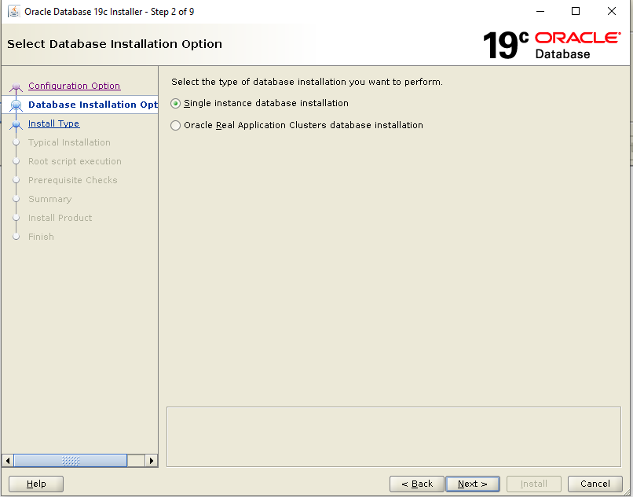

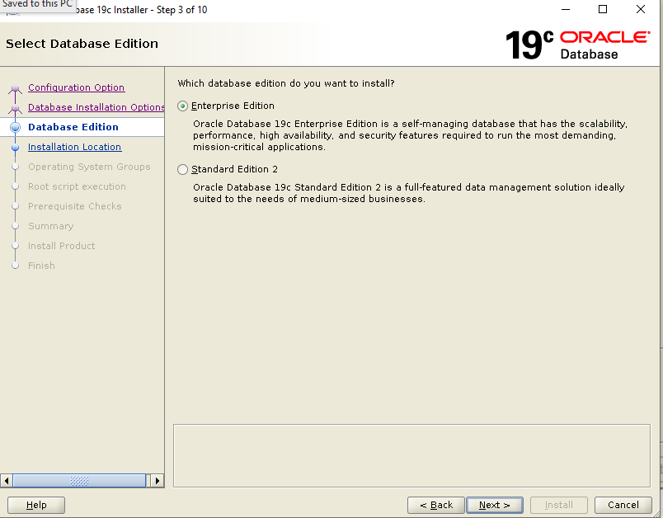
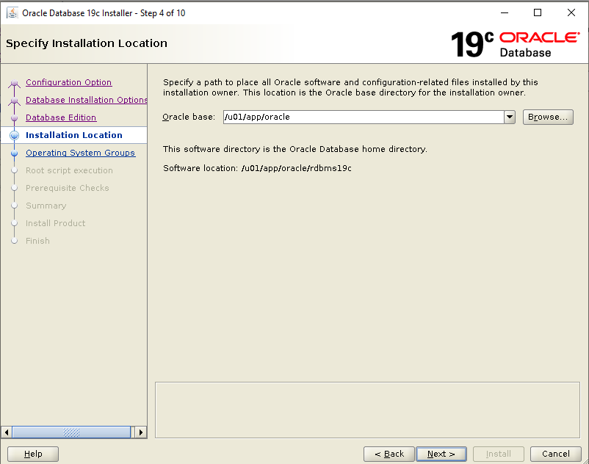
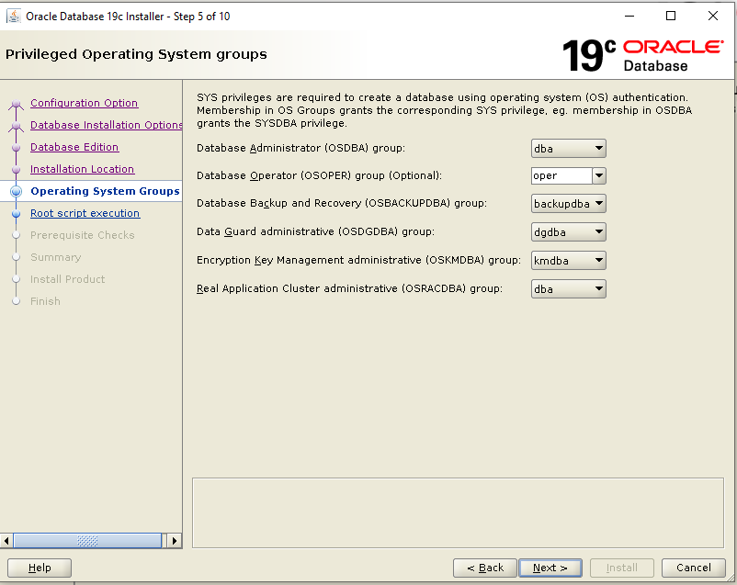
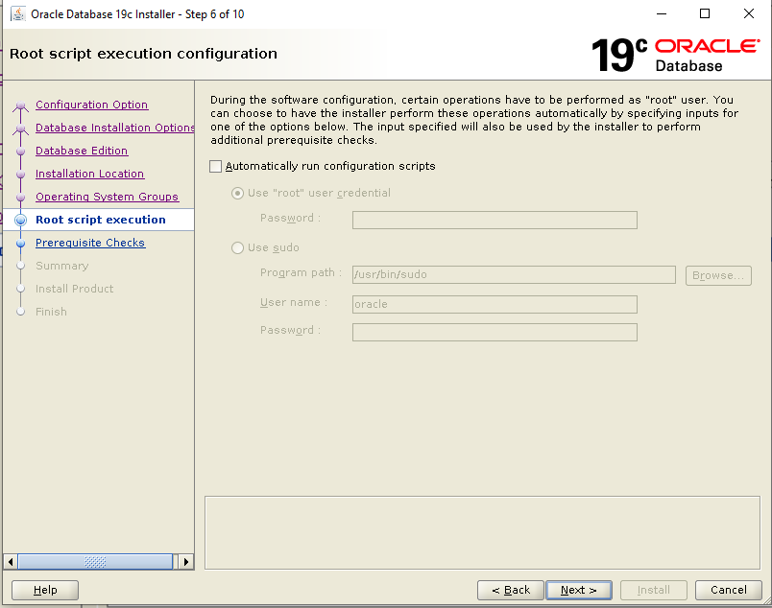

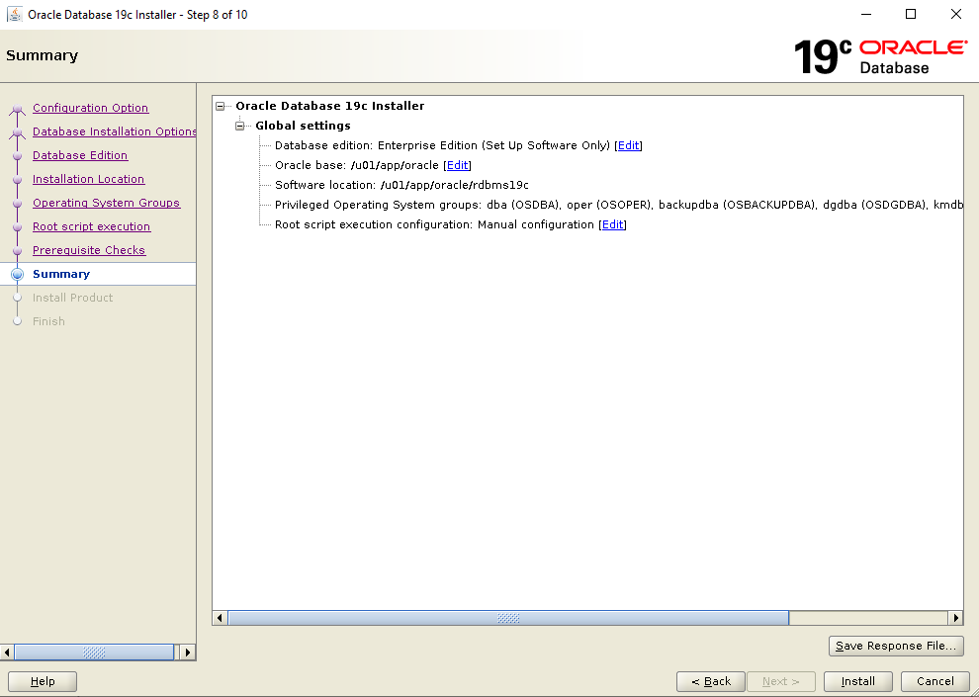

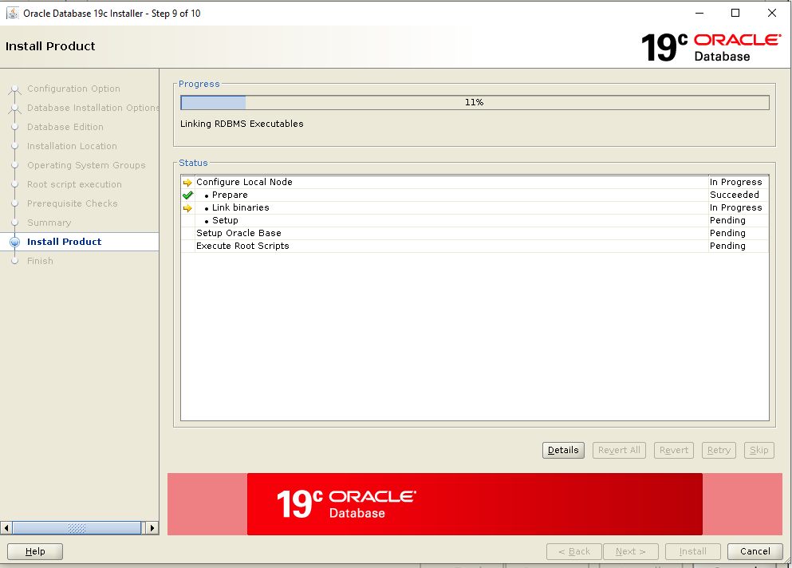
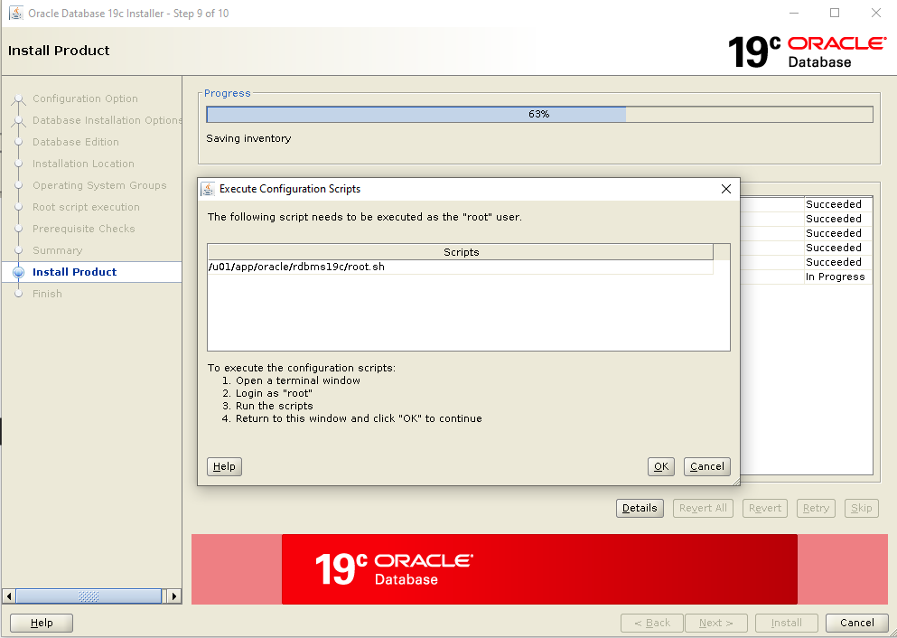
Run the script as root user.
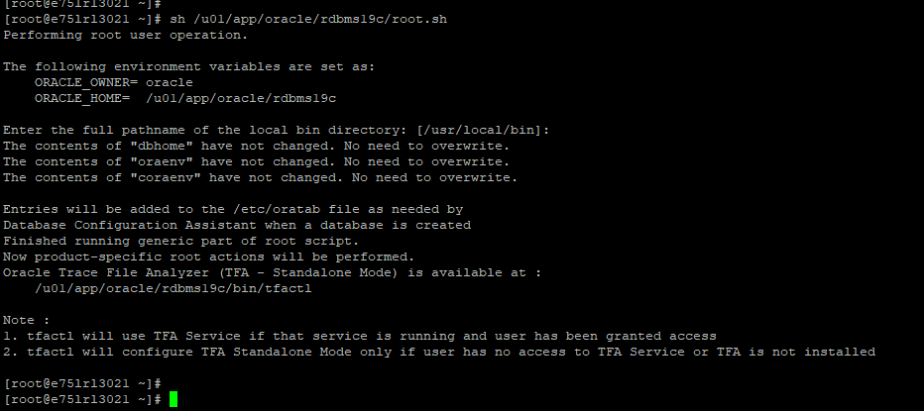
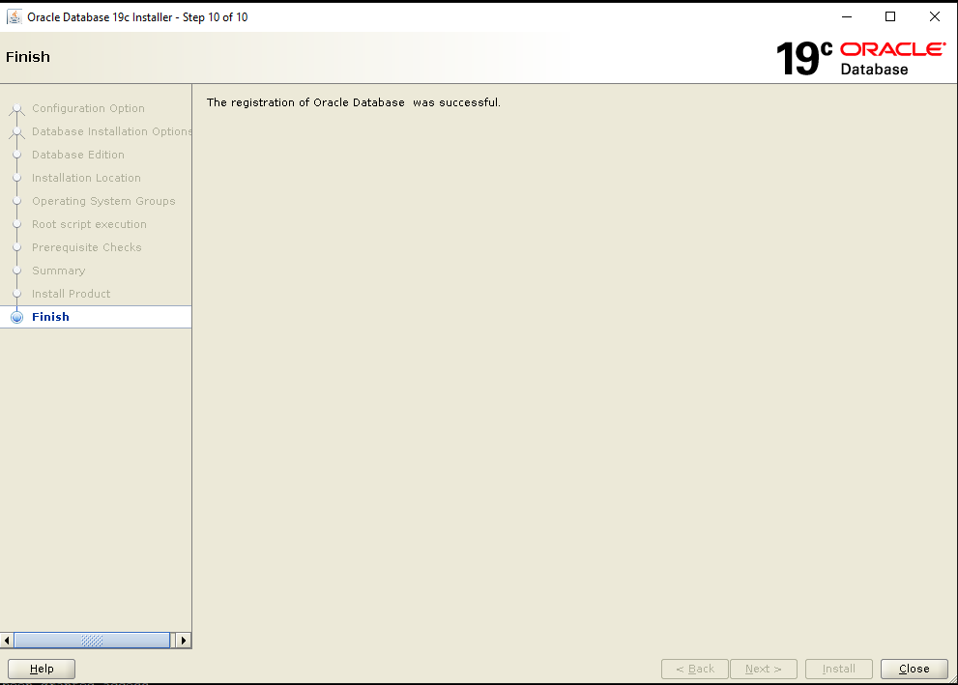

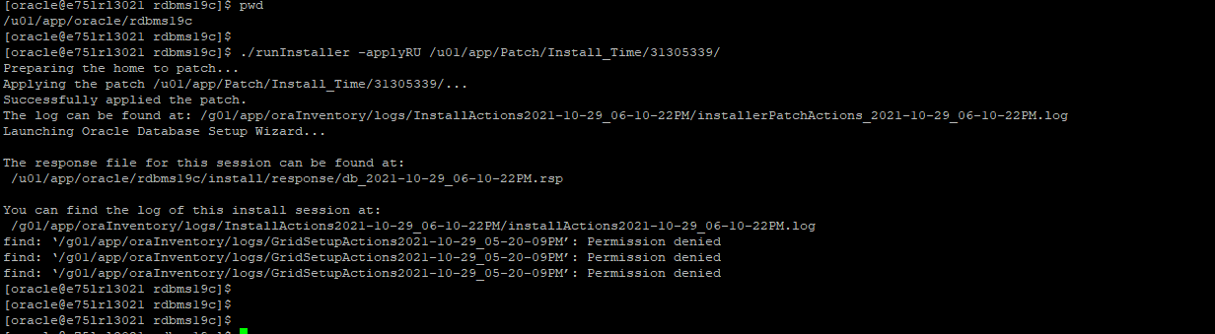

Update listener parameter
- Add the below parameter in listener file and restart the listener alone. Then both SID & SERVICE_NAME will work fine for PDB’s
- listener file location:
/g01/app/grid/oracle19c/network/admin/listener.ora

USE_SID_AS_SERVICE_listener=on

Restart listener after updating the password.

Cleanup vulnerable files from installation.

END OF DOCUMENT

